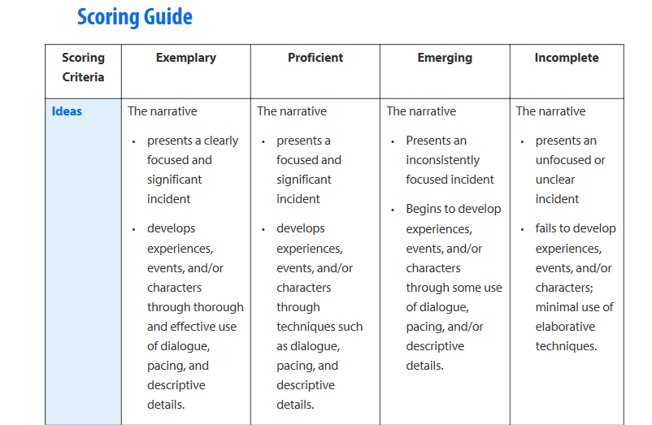

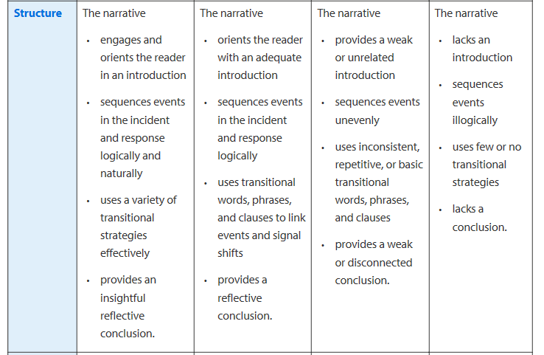
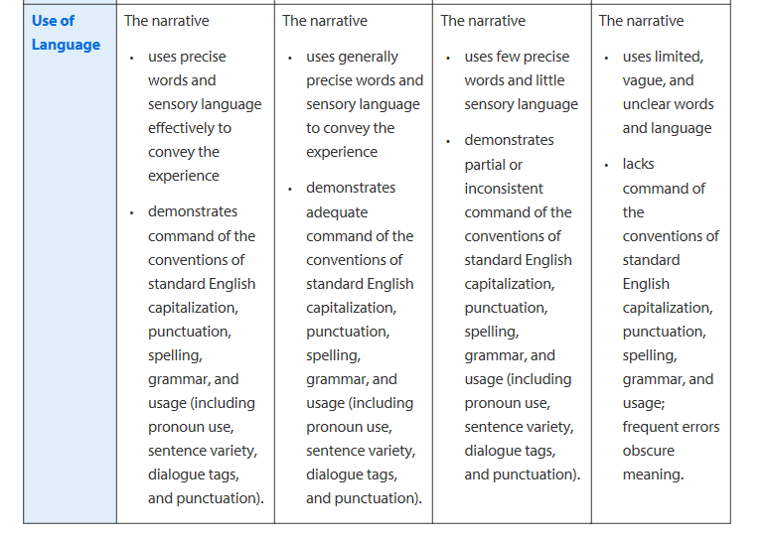

Final grade: ____________________________
Ms. Hosford’s comments: __________________________________________________________________________________________________________________________________________________________________________________________________________________________________________________________________________________________________________________________________________________________________________________________________________________________________________________________________________________________________________________________________________________________________________________________________________________________________________________________________________________________________________________________________________________________________________________________________________________________________________________________________________________________

